To log into the RF Report Center and access the Principal Investigator (PI) and RF Award Interface Reporting (RF AIR) dashboards, follow these simple steps:

- Go to http://www.rfsuny.org.

- Do not click on the LOG IN link at the top. That is for the RF Portal. If you already logged in using that link, you’ll have to log out and start over. Instructions for logging out of the RF Portal are below.
- Instead, Scroll down to Information For: Researchers, then click on RF Report Center.
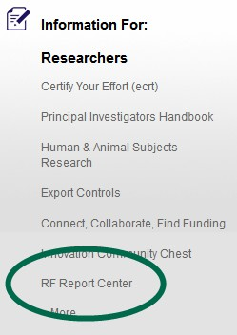
- You can also scroll down to Administrators and click on the same RF Report Center link.
- Click on the RF Report Center logo.
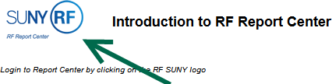
- Scroll down to and click on the Stony Brook University logo.


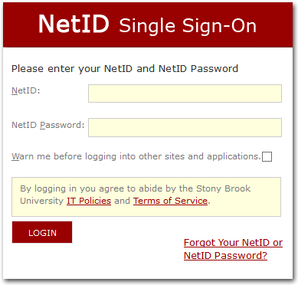
- If you are not already logged into Stony Brook’s SSO service, login using your NetID and NetID password. (Your NetID is the typically same ID you use to log into your computer and is typically your first initial followed by your last name. It is not your nine-digit SOLAR ID.) If you are already logged into Stony Brook’s SSO service, the system will skip this step.
- In the upper right-hand side of the screen, click on the Dashboards drop-down list, then select either Principal Investigator or RF Activity Interface Reporting.
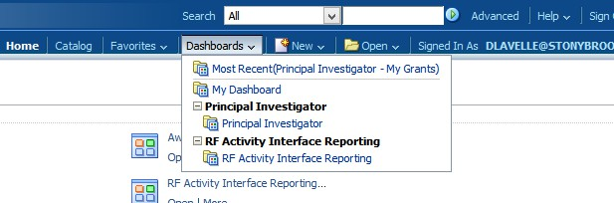
If you have previously used the RF Portal Login, you must first log out, and then follow these instructions from the top.
